ASSIGNMENT NO.01
TITLE: To Relate the entities appropriately. Apply cardinalities for each relationship. Identify strong and weak entities, relationships between entities, attributes, keys, cardinalities, generalization and specialization etc wherever required.

PROBLEM STATEMENT: Convert the ER diagram into relational tables and normalize Relational data Model.

OBJECTIVES:
- To list and understand ER model and Normalization
- Use database techniques such as Entities, cardinalities, generalization and specialization

OUTCOMES:
- Students will able to create Conceptual design using ER
- Students will be able to write schema for given requirements using ER model

SOFTWARE & HARDWARE REQUIREMENTS:
- 64-bit Open source Linux or its derivative
- MySQL Server

THEORY:
- ER model stands for an Entity-Relationship model. It is a high-level data model. This model is used to define the data elements and relationship for a specified system.
- It develops a conceptual design for the database. It also develops a very simple and easy to design view of data.
- In ER modeling, the database structure is portrayed as a diagram called an entity-relationship diagram.
For example, suppose we design a school database. In this database, the student will be an entity with attributes like address, name, id, age, etc. The address can be another entity with attributes like city, street name, pin code, etc and there will be a relationship between them.

Component of ER Diagram
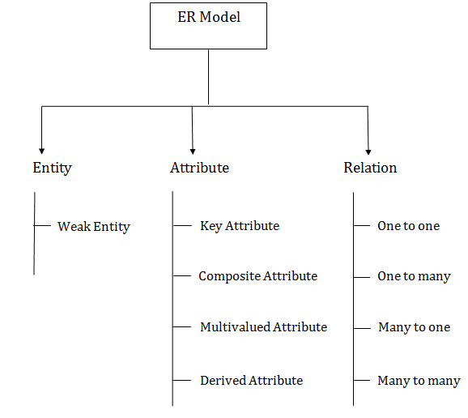

1. Entity:
An entity may be any object, class, person or place. In the ER diagram, an entity can be represented as rectangles.
Consider an organization as an example- manager, product, employee, department etc. can be taken as an entity.
- Weak Entity
An entity that depends on another entity called a weak entity. The weak entity doesn't contain any key attribute of its own. The weak entity is represented by a double rectangle.
2. Attribute
The attribute is used to describe the property of an entity. Eclipse is used to represent an attribute.
a. Key Attribute
The key attribute is used to represent the main characteristics of an entity. It represents a primary key. The key attribute is represented by an ellipse with the text underlined.
b. Composite Attribute
An attribute composed of many other attributes is known as a composite attribute. The composite attribute is represented by an ellipse, and those ellipses are connected with an ellipse.
c.Multivalued Attribute
An attribute can have more than one value. These attributes are known as a multivalued attribute. The double oval is used to represent a multivalued attribute.
d. Derived Attribute
An attribute that can be derived from other attribute is known as a derived attribute. It can be represented by a dashed ellipse.

3. Relationship
A relationship is used to describe the relation between entities. Diamond or rhombus is used to represent the relationship.
Types of relationship are as follows:
a. One-to-One Relationship
When only one instance of an entity is associated with the relationship, then it is known as one to one relationship.
b. One-to-many relationship
When only one instance of the entity on the left, and more than one instance of an entity on the right associates with the relationship then this is known as a one-to-many relationship.
c. Many-to-one relationship
When more than one instance of the entity on the left, and only one instance of an entity on the right associates with the relationship then it is known as a many-to-one relationship.
d. Many-to-many relationship
When more than one instance of the entity on the left, and more than one instance of an entity on the right associates with the relationship then it is known as a many-to-many relationship.

NORMALIZATION

AIM: Apply the database Normalization techniques for designing relational database tables to minimize duplication of information like 1NF, 2NF, 3NF, BCNF.
Normalization is a process of converting a relation to be standard form by decomposing a larger relation into a smaller efficient relation that depicts a good database design.
- 1NF: A Relation scheme is said to be in 1NF if the attribute values in the relation are atomic.i.e., Mutli –valued attributes are not permitted.
- 2NF: A Relation scheme is said to be in 2NF,iff and every Non-key attribute is fully functionally dependent on primary Key.

- 3NF: A Relation scheme is said to be in 3NF,iff and does not have transitivity dependencies. A Relation is said to be 3NF if every determinant is a key for each & every functional dependency.
- BCNF: A Relation scheme is said to be BCNF if the following statements are true for eacg FD P->Q in set F of FDs that holds for each FD. P->Q in set F of FD’s that holds over R. Here P is the subset of attributes of R & Q is a single attribute of R.
The given FD is a trival
P is a super key.

CONCLUSION:

QUESTIONS:

Sample Database: movie
The sample database represents some of the data storage and retrieval about a movie related industry. Most of the people love to watch movies, and for all of them we are providing sample information about the movie related questions coming to their mind. This design of the database will make it easier for movie lovers to know the curiosities about the movies.
Following are the below diagrams , write the ER Model and Schema design.
